Q 1 Assume there is a table called Multicust, with all of the same column definitions as SALESPEOPLE. Write a command that inserts all salespeople with more than one customer into this table.

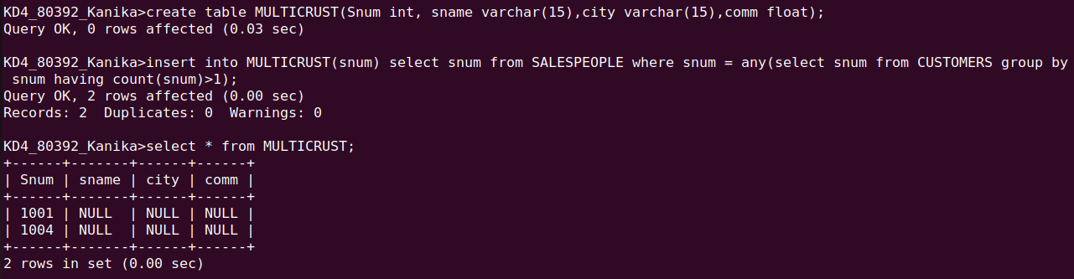

Q2 Write a command that deletes all customers with no current orders.

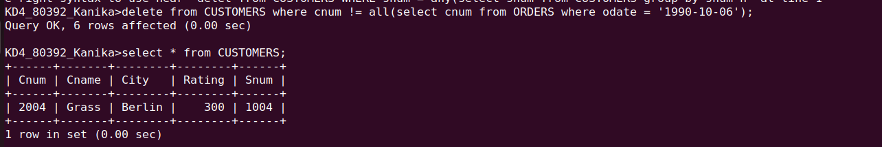

Q 3 Write command that increases by twenty a percent the commissions of all salespeople with total orders above Rs. 3,000.
